**NEPAL COLLEGE OF INFORMATION TECHNOLOGY**

**Balkumari, Lalitpur**



**A Lab Report**

**On**

**Subject:- Web Technology**

**Lab Report # _1__.**

**Title: - Introduction to HTML**

**Submitted by:- Submitted to:-**

**Name : - Abiral Chaudhary Instructor: - Simanta Kasaju**

**Roll No:- 221702 Department :- software**

**Faculty: - science and technology Submission Date:2080/02/24**

**Semester:-II**

**VS Code**

Visual Studio Code, commonly known as VSCode, is a free and open-source code editor

developed by Microsoft. It supports a wide range of programming languages, and

features include debugging, syntax highlighting, and Git integration. Its popularity has

made it one of the most widely used code editors among developers.

**Theory: -**

•HTML was developed by Tim Berners-Lee in late 1991 s.

•HTML stands for Hypertext Markup Language. It is a formatting language which uses

tags for preparing documents.

•The structure of HTML id based on a system of tags and attributes that define the

elements of a web page.

•It is used to design the structure of the webpage using tags and elements , it provides

basic frame to the webpage.

•There are many text editors can be used to create HTML files and must be saved with

extension .htm or .html but html is more preferred.

•The proper use of tags and attributes is essential for creating well-structured and

accessible HTML documents

**Structure Of HTML:<head> —----------------------------------------------->head(open)**

**<title>Title of webpage</title> —-------------------->title element**

**<!Doctype html> --------------------------------------> Doctype declaration**

**<html> —------------------------------------------------->Root element**

**</head> —------------------------------------------------>head (close)**

**<body> —-------------------------------------------------> body(close)**

**<h1>heading</h1> —---------------------------------->heading element**

**<p>content</p> —--------------------------------------->paragraph element**

**</body> —------------------------------------------------->body(close)**

**</html> —-------------------------------------------------->Root(close)**

**HTML Editors:-**

VS Code,Sublime text,Notepad,Notepad++,etc are some HTML editors.

**HTML Tags: -** HTML tags are like a set of keywords that defines how the page will be

formatted and displayed in a web page. There are two types of tags they are

1. **Paired tags:** Tags that have both opening and closing tags .

Eg:<p>content<p>

2**. Unpaired tags:** Tags that have only single tags

| **Element Name** | **Description** |
| --- | --- |
| **<b>** | Used to bold text |
| **<strong>** | This is a logical tag, which tells the browser that the text is important. |
| **<i>** | This is a physical tag which is used to make text italic |
| **<mark>** | This tag is used to highlight text. |
| **<u>.** | This tag is used to underline text written between it |
| **<tt>** | This tag is used to appear a text in teletype.(not supported in HTML5) |
| **<strike>** | This tag is used to draw a strikethrough on a section  of text. (Not supported in HTML5) |
| **<sup>** | It displays the content slightly above the normal line. |
| **<sub>** | It displays the content slightly below the normal line. |
| **<del>** | This tag is used to display the deleted content. |
| **<ins>** | This tag displays the content which is added |
| **<big>** | This tag is used to increase the font size by one conventional unit. |
| **<small>** | This tag is used to decrease the font size by one unit from base font size. |
| **<br>** | This tag is used to add a line break. |
| **<hr>** | This tag is used to insert horizontal lines. |
| **<h1>** | It is used to specify the heading. |
| **<dfn>** | It specifies the topic going to be defined. |
| **<blockquote>** | Used to specify if copied from another source. |
| **<q>** | This tag is used for short quotations. |
| **<kbd>** | This tag is used to define keyboard input |
| **<code>** | This tag is used to define pieces of computer code. |
| **<address>** | Used to provide address of author/owner |
| **<!—comment-- >>** | Used to write comment in HTML |
| **<em>** | This is a logical tag which is used to display content in italic. |

**Question-1**

**code:-**

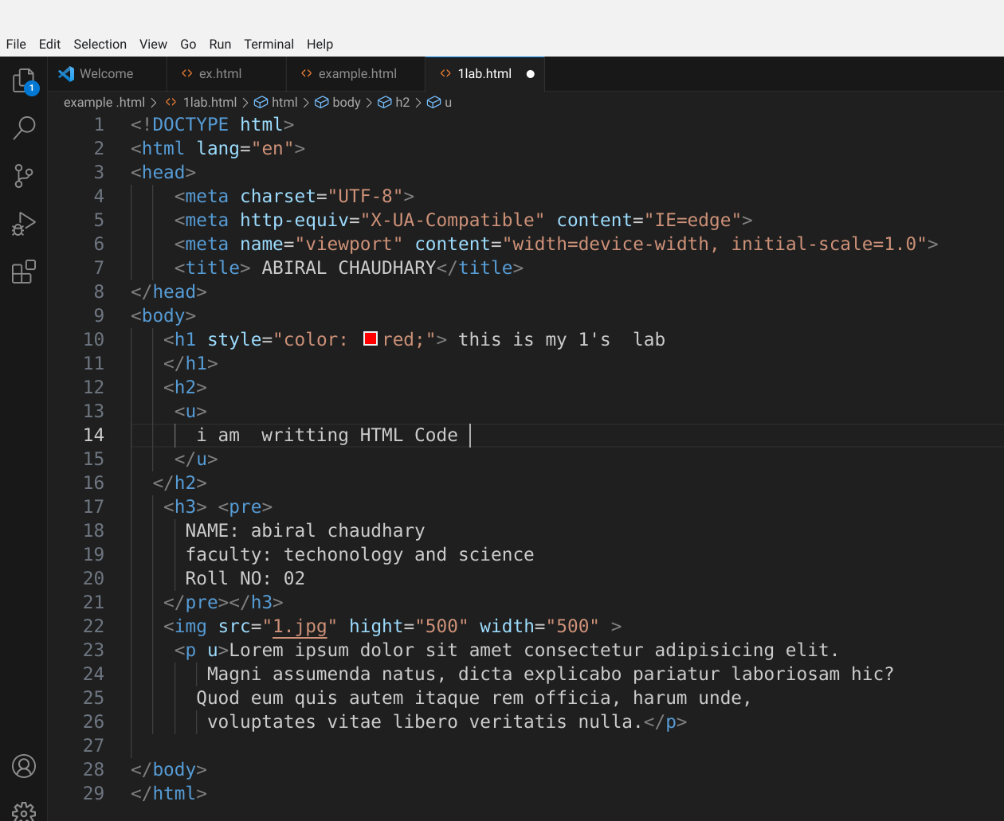

**output:-**